WHITE PAPER
Addressing Email Archiving and Discovery with Microsoft® Exchange Server 2010

Introduction
With businesses generating and sharing an ever-increasing volume of information through email, the ability to protect and preserve these critical communications is essential. Whether your motivation is to improve storage management, meet regulatory requirements for data retention, or lower the costs of conducting electronic discovery (e-Discovery), implementing an effective email archiving and discovery solution can offer a number of benefits.
Even though there are clear-cut drivers for adopting such solutions, a significant number of organizations rely instead on potentially less efficient means to store and search these enormous amounts of data. For example, when users have small mailbox quotas, they often archive older messages into local Microsoft® Outlook® Data Files (.PST files), removing this important historical record from Exchange Server. With these messages no longer under the direct control of your IT department, it can be very challenging for your organization to comply with regulations or respond in a timely fashion to e-Discovery requests.
To help you more effectively address these needs, Microsoft Exchange Server 2010 introduces integrated email archiving, retention, and discovery capabilities. These built-in tools can help you simplify the process of preserving and discovering email without having to change the way your users or administrators work with and manage Exchange Server.

The importance of archiving email
From mitigating the risks associated with the annual double-digit percentage increases in legal disputes to finding ways to reduce your storage costs, the motivations for deploying a comprehensive solution for archiving email are best summarized as the following:
- Optimizing storage management to lower costs
- Complying with industry and regulatory data retention requirements
- Streamlining discovery processes to ease the burden of responding to legal orders
Challenges with current approaches
While organizations strongly desire the real benefits of archiving email, many have faced complexity and challenges that have either stalled or prevented the successful deployment of an adequate solution.
“PST files are quite a nightmare for IT to manage. We look forward to Exchange 2010 negating the need for supporting PSTs. It’s going to take a lot of headaches away for us.”
– Ronald Loewenthal Customer Service Manager, Super Group
First, email can be stored in numerous locations across your network. Email can be found in .PST files, posted to Microsoft SharePoint® sites, stored on backup tapes, hosted on third-party solutions, or even forwarded by your users to their personal email accounts. With the potential of up to 90 percent of your email residing outside of your Exchange Server, it can be daunting to enforce data retention policies or locate relevant communications when compliance matters arise.
Additionally, many email archiving approaches introduce an environment that is unfamiliar to both your users and IT administrators. For instance, users often need to leave the familiarity of Microsoft Outlook to interact with their archived email. They will likely need to learn new skills and client applications to search or access archived messages. This can disrupt the normal workflow for managing their inboxes. In many situations, email is archived out of Exchange and into separate data repositories, which could result in a loss of features that boost user productivity—such as the new Conversation View or the “anywhere access” benefits of Outlook Web App—that likely led you to choose Exchange to begin with.
For your IT department, complexity can arise from having to deploy and maintain Outlook and Outlook Web App add-ins to enable user access to archived email. When it comes to administrative tasks, there could be a range of challenges to learning and implementing yet another infrastructure that needs to be as reliable and easy to access as your Exchange Server. And, your IT staff may experience the added burden of having to utilize different methods to conduct mailbox searches across recent email in Exchange and messages archived to another repository—all to perform queries on behalf of your organization’s compliance officers, legal department, or human resources.
Lastly, there is cost. Not only do you need to deploy and operate a separate infrastructure that runs in parallel to your business critical email platform, you’ll need to train your users and support increased help desk call volume as users learn new tools for managing their email. All of these can lead to higher operational costs in a time when every business is seeking to transform IT into a competitive asset by driving down the costs and overhead of infrastructure investments.

A different approach to email archiving
Recognizing the importance of deploying an effective archiving and discovery solution, Microsoft has delivered new, integrated email archiving, retention, and discovery capabilities with the release of Exchange Server 2010. These built-in features (Figure 1) were designed with an appreciation for the potential barriers that have limited wide scale adoption of email archiving. They can help you preserve and discover email without having to alter either the user or IT professional experience.
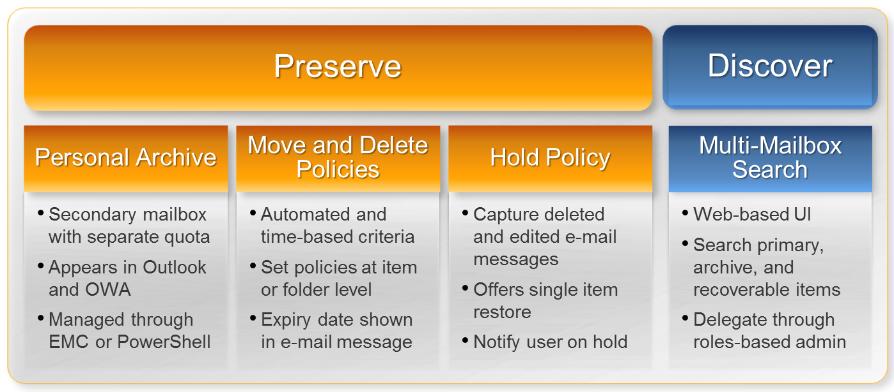
Figure 1: Integrated email archiving features of Exchange Server 2010
Delivering a familiar experience
When organizations have small mailbox quotas in place, users spend valuable time trying to stay below these limits by either deleting email from their inboxes or offloading it to their PCs in the form of .PST files. While .PST files provide an intuitive user experience, their creation isolates this email on individual desktops. As highlighted previously, this can make it challenging for your organization to meet industry and regulatory requirements around email retention and timely e-Discovery. For example, when a discovery request is made, .PST files must be retrieved and searched manually—a potentially time-consuming and costly process. Similarly, legal holds and message expiration policies cannot be enforced consistently.
Through the introduction of a new, integrated Personal Archive in Exchange 2010, email currently stored in .PST files or other locations can be easily moved back to the server.
The Personal Archive is a specialized, secondary Exchange mailbox that is uniquely associated with a user’s primary mailbox. It offers your users an alternative storage location for their historical email, greatly reducing the need for and proliferation of .PST files. Email items from a user’s primary mailbox can be automatically offloaded to the Personal Archive through Retention Polices (see below). Administrators also have the option to import historical email from existing .PST files† directly into Exchange.
Both you and your users will immediately benefit from having all of your organization’s important email back under IT department control. All of your email can be better protected thanks to built-in high availability features and policy management, while your users gain the improved business mobility they often demand.
When implemented in conjunction with the large mailbox investments made in Exchange 2010, you can cost-effectively manage both current and archived email in a single platform. Specifically, Exchange 2010 enables you to take advantage of high-capacity, low-cost disks. Combined with the significant IO savings and built-in mailbox resiliency technologies delivered in this release, you now have more choices at your disposal to meet your storage management requirements without having to break your budget. You also have the flexibility to provision and manage archive mailboxes on separate Exchange databases†, allowing you to implement alternative storage strategies for less frequently accessed email data.
Figure 2: A familiar experience with Personal Archive appearing in Outlook Web App
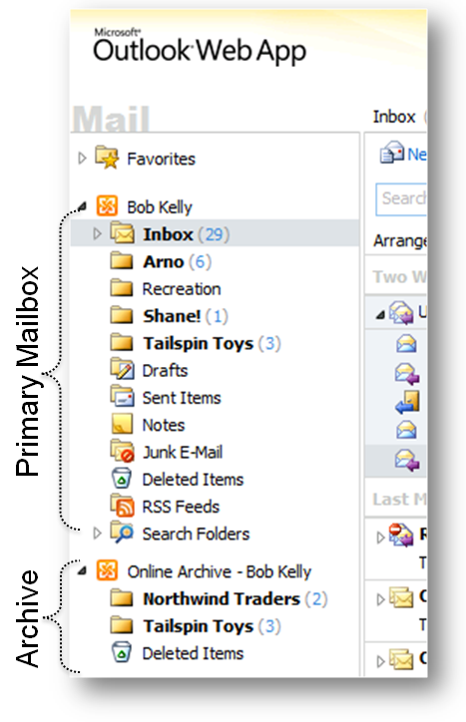
To help deliver a familiar user experience, the Personal Archive appears alongside primary mailbox folders in both Outlook and Outlook Web App (Figure 2). Just like any other folder or opened .PST file, your users can easily interact with archived email using existing skills. For example, they can “drag and drop” email messages to their Personal Archive, create folders, set flags, reply to messages, and even conduct searches across archived email, all within Outlook and Outlook Web App. This greatly reduces the need for costly user training or additional support resources when rolling out a new archiving solution.
For your administrators, the same tools that they use to manage other aspects of Exchange Server—such as the Exchange Management Console or PowerShell—can be used to configure and deploy the Personal Archive. This includes tasks like setting separate storage quotas for the Personal Archive, enabling delegate access to the archive†, and importing email from existing .PST files into Exchange†.
Flexible and granular retention policies
To help you meet a wide array of company, industry, or regulatory requirements, Exchange 2010 includes an improved approach to managing message retention. You can define and deploy Retention Policies (Figure 3) which automate the deletion and archiving of email and other Exchange item types.
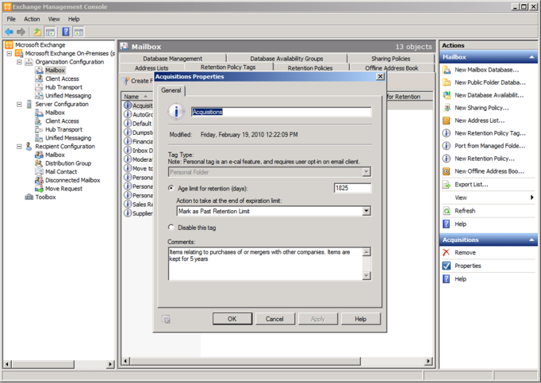
Retention Policy Tags (Figure 4) can be created to apply retention settings to default folders, such as the Inbox and Sent Items. Exchange then performs specified retention actions once the item has reached its retention age. Actions can include moving the message to the user’s Personal Archive, moving it to the Deleted Items folder, or permanently deleting the item. You can allow users to assign personal retention policies to individual messages, conversations, or custom folders to ensure proper message expiry is set on important email. This allows your users to adapt email retention and message classification to their individual work styles.
Figure 3: Easily create and deploy Retention Policies from the Exchange Management Console†
As items are moved from one folder to another, they can inherit any Retention Policy Tags applied to the folders to which they moved. If an email is moved to a folder that does not have a policy assigned, the default retention policy set by your Exchange administrators will be applied to it. If the item has been tagged explicitly by a user, this retention setting takes precedence over folder-level or default tags. Outlook 2010 displays retention policy details right in the message preview pane. This removes the need for your users to monitor a specific folder to learn which messages may be expiring soon.
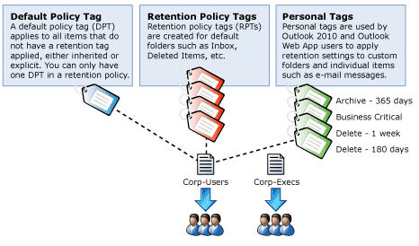
Retention policies work seamlessly across both the primary mailbox and Personal Archive. Both types of policies (Delete and Move to archive) can be combined on the same item or folder. For example, an email can be tagged so that it is automatically moved to the Personal Archive in ‘x’ days and then deleted within ‘y’ days.
Exchange 2010 also adds a new Legal Hold policy. Legal Hold enables the preservation of any edits to or deletions of email made by the user placed on hold, whether in their primary mailbox or Personal Archive. Altered messages are captured in a recoverable items store within Exchange that is neither accessible to nor changeable by the user.
Figure 4: Different Retention Policy Tag types available in Exchange Server 2010
Legal Hold can be set on individual mailboxes or across the enterprise and can be set for a specific time period (for example, hold items for 90 days). Legal Hold also includes an option that automatically alerts users through Outlook 2010 that a hold has been placed on their mailbox.
You can apply Retention Policies and Legal Hold even if a user does not have a Personal Archive provisioned. For example, your organization may choose to simply deploy large mailboxes without Personal Archives. Legal Hold can still be used to preserve email to comply with data retention requirements.
Powerful multi-mailbox search
Exchange 2010 simplifies the e-Discovery process with a new, Web-based, easy-to-use Multi-Mailbox Search feature. This capability can be delegated to specialist users, such as compliance officers, who are normally tasked with conducting e-Discovery for range of legal, regulatory, or personnel reasons. Thanks to the new role-based security model of Exchange 2010 you can offload this burden confidently without having to provide full administrative privileges.
“We used to spend one or two days looking for information we needed for legal requirements. Now, with multi-mailbox search in Exchange Server 2010, we can find what we need in an hour or less.”
– Julio Sandoval
Head of Middleware,
Binaria
Based on the content indexes created by the built-in Exchange Search, Multi-Mailbox Search provides rich, keyword-based search criteria (using Advanced Query Syntax) for an assortment of Exchange message types such as email, calendar appointments, and instant messaging conversations. Exchange 2010 also indexes a long list of attachment types as well as messages protected using Information Rights Management (IRM).
You can select a specific mailbox or mailboxes—even distribution groups—as targets of the search. And, a single search query automatically includes relevant email found in a user’s primary mailbox, Personal Archive, and recoverable items store.
A search preview† provides details on the estimated number of results including keyword statistics to help you conduct early case assessments or fine-tune search criteria. Once satisfied with the search parameters, results can be copied to a specialized mailbox specifically created for discovery purposes. A new folder is created in the target mailbox for the search with subfolders for each user mailbox containing relevant messages. These messages are copied to a folder that has the same name and location as it appears in the original mailbox, preserving the folder hierarchy. Optional de-duplication of search results† allows for copying of only one instance of messages, and facilities right in Outlook Web App allow you to easily annotate† reviewed items help make your e-Discovery workflow more efficient. The result: you no longer need to export results to a .PST file and manually import them into Outlook to review your search.
Lastly, Multi-Mailbox Search logging options allow you to capture information about conducted searches. For instance, a comma separated value (CSV) file can be created that contains details on the query, the mailboxes searched, all the items in the search results, and attributes of these messages.

Third-party email archiving solutions
While you’ll likely find that the built-in archiving and discovery capabilities in Exchange 2010 meet your organization’s needs, we’ve also made it possible for Microsoft independent software vendor partners to extend our archiving, retention, and discovery feature set through scalable Web services interfaces. Microsoft is working closely with a number of leading archiving and compliance solution providers to deliver additional tools that build upon the functionality delivered in Exchange 2010 to help you address specialized or industry-specific compliance or e-Discovery needs. Most importantly, you will be able to preserve familiar user and IT professional experiences. For more information on partner solutions for Exchange 2010, visit microsoft.com/exchange.

Conclusions

There are likely many reasons your organization is seeking new and better ways to preserve and discover the critical business communications conducted over email. Whether your motivation is to lower your storage costs, address regulatory compliance, or meet time tables for legal discovery orders, the integrated email archiving, retention, and discovery features offered in Exchange 2010 can help your organization:
- Deliver a seamless experience without interrupting your users’ email workflow.
- Streamline administrative tasks using familiar management tools and delegation.
- Reduce costs and lower administrative overhead through integrated capabilities.

†Available with Exchange Server 2010 Service Pack 1 (SP1)

“The Microsoft Large Mailbox Vision” - http://www.microsoft.com/downloads/details.aspx?FamilyID=e3303d34-af6c-4108-861b-dc05f9cf3e76&displaylang=en
Requires Outlook 2010 or Outlook 2007†

